**Topic:** Great Theorem: Euclid’s proof of the Pythagorean Theorem

**Notes on Topic:**

Unlike some of Euclid’s proofs, which are believed to belong to other mathematicians in origin, the proof of this theorem is Euclid’s own.

As we have seen, *Elements* builds upon itself and relies on previously proven propositions to prove later propositions.

We have seen the previous 46 propositions, they have not touched on quadrilaterals other than parallelograms, circles were not discussed, similarity wasn’t touched on until book VI. The Pythagorean theorem can be proven simply with the use of similar triangles, but Euclid did not want to wait until Book VI.

The first book was leading toward this theorem, which makes it a great finale for the great book.

Note: Euclid’s expression is not about the algebraic pythagorean theorem, but rather the geometric expression that literally describes squares being constructed on the three sides of the right triangle.

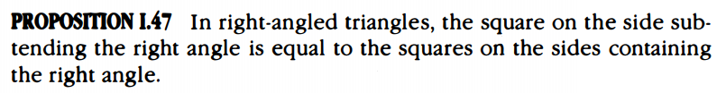

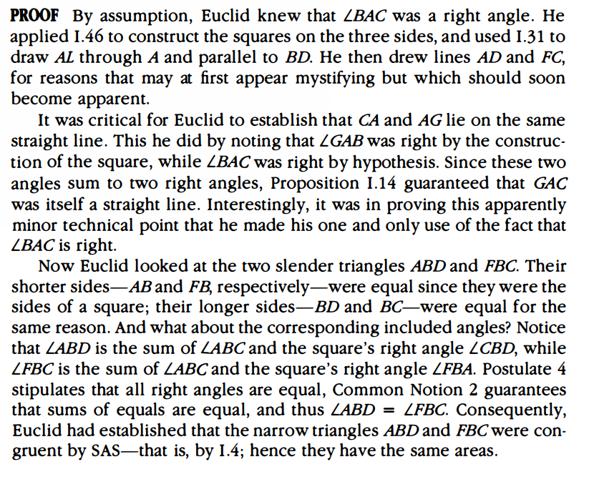

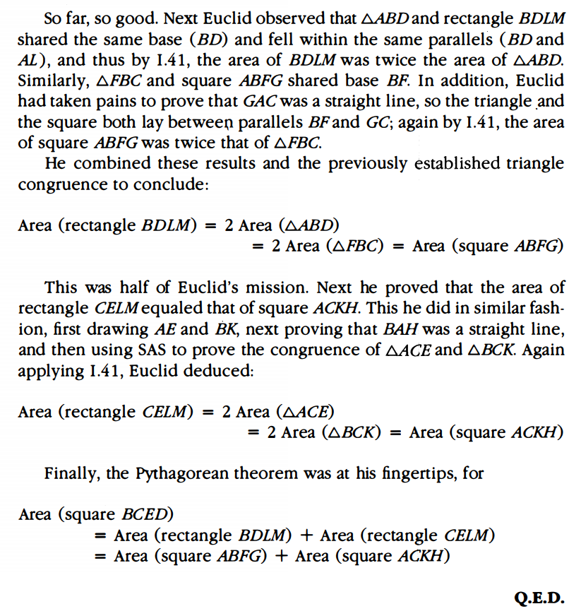

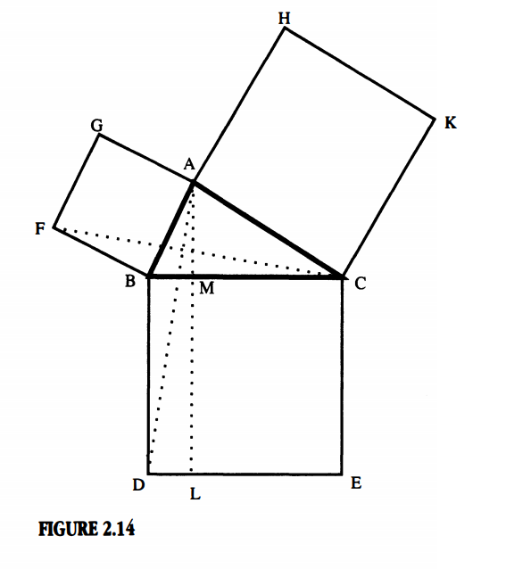

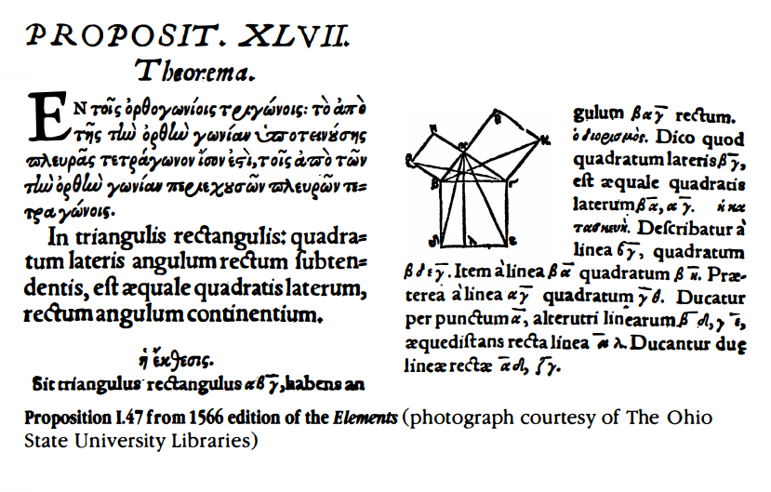

There was one more proposition Euclid set out to prove, the converse of the pythagorean theorem.

This proof deserves a spotlight shown on two different elements; first, it is quite short, especially compared with the previous proposition. Second, it involves the use of the pythagorean theorem, which is a rare approach to any converse proof.

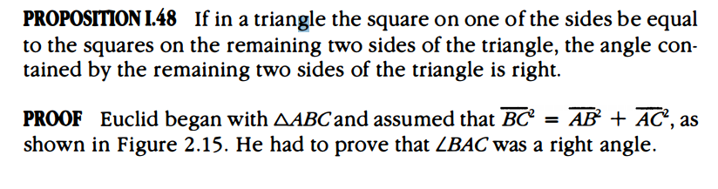

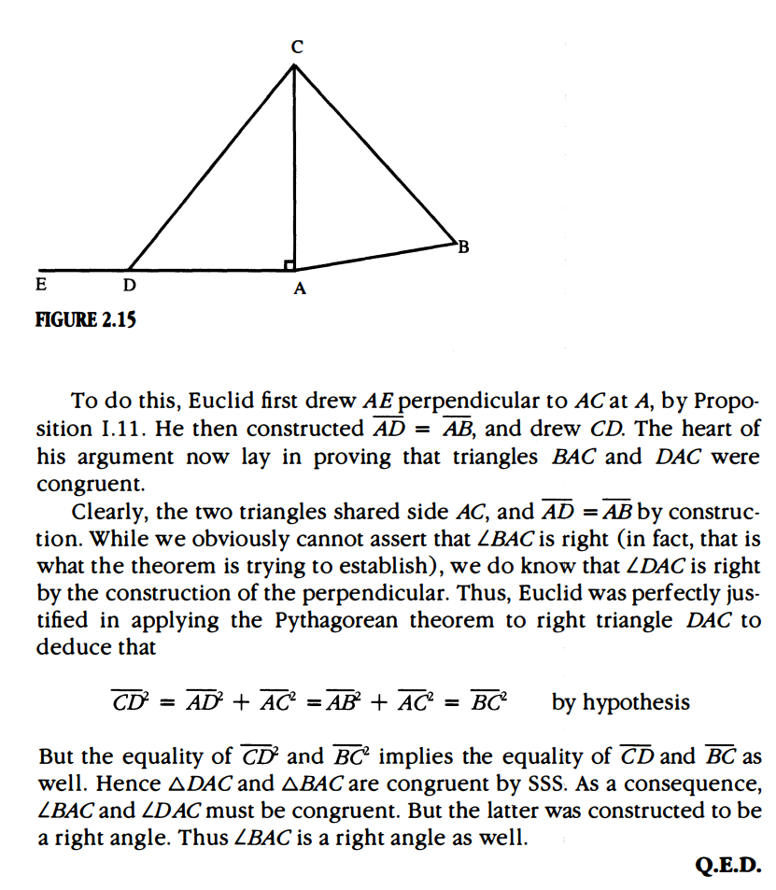

**Additional Suggested Reading**: Epilogue, Chapter 2

**Assignment:** Homework Problem 20, 22, 26, 28, 29(EC), 31(EC)